|  |
| --- |
|  |
| 新概念 3 册 |
| Lesson49 |

Lesson 49 The ideal servant



**rambling ['ræmblɪŋ]**

**adj. 不规则的，布局凌乱的**

rambling adj. (esp. of buildings, streets, towns, etc.) extending in various directions irregularly

（尤指建筑物、街道、城镇等）无规则地向各方延伸的，布局凌乱的

She had a huge, rambling country house called 'The Gables'.

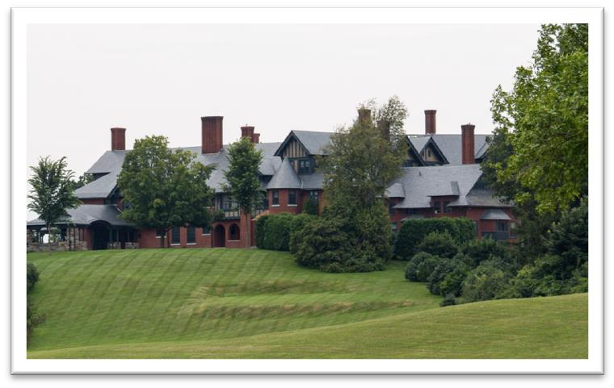

ramble v.& n. 漫步，闲逛

I like rambling in the country.

There's plenty to discover as you ramble around this little island. I quite like the idea of going for a ramble one weekend.

rambler n. 漫步者

Exploring really deep caves is not a task for the Sunday afternoon rambler.

sentimentally [sentɪ'mentəlɪ]

**adv. 情感上；多情地**

sentimental adj. 1. relating to emotions instead of reason 情感的（而非理智的）

for sentimental reasons

He wasn't the sort of person who kept things for sentimental reasons.

sentimental value

The rings that were stolen were of great sentimental value. have a sentimental attachment to …

He had a sentimental attachment to his birth-place.

sentimental adj. 2. making people experience feelings of sadness, sympathy, love, etc., especially in a deliberate and obvious way 煽情的

a sentimental song / book / movie

sentimental adj. 3. expressing feelings of sadness, sympathy, love etc., especially in a way that seems inappropriate 多愁善感的

I'm just a sentimental old man. sentimentally adv.

be sentimentally attached to …

The couple are sentimentally attached to each other.

She was sentimentally attached to this house, for even though it was far too big for her needs, she persisted in living there long after her husband's death.

preside [prɪ'zaɪd]

**v. 主持（会议等）；掌管，领导**

preside at … 主持……

I shall be pleased to preside at your meetings.

They asked if I would preside at the committee meeting. preside over … 掌管，领导

The city council is presided over by the mayor. Finch presided over the company for 30 years.

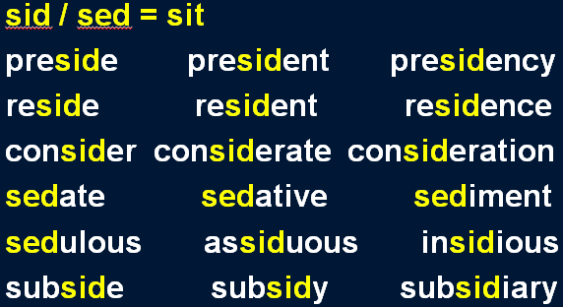Aunt Harriet presided over an invisible army of servants that continuously scrubbed, cleaned, and polished.

However, there is an even more insidious kind of pollution that particularly affects urban areas and invades our daily lives, and that is noise.

An all-night party on New Year's Eve, provided me with a good excuse for not carrying out either of these new resolutions on the first day of the year, but on the second, I applied myself assiduously to the task.

I wanna hold you till I die, till we both break down and cry. I wanna hold you till the fear in me subsides.

unrelenting [ʌnrɪ'lentɪŋ]

**adj. 不屈不挠的；持续不断的**

unrelenting adj. 1. extremely determined, never weakening in effort or admitting defeat 非常坚决的，不屈不挠的

He was unrelenting in his search for the truth about his father.

She will be remembered as an unrelenting opponent of racial discrimination.

unrelenting adj. 2. an unpleasant situation that is unrelenting continues for a long time without stopping（不愉快的事）持续不断的

an unrelenting downpour of rain the unrelenting pressures of the job relentless

her relentless pursuit of perfection

a regime that was relentless in its persecution of dissidents the relentless crying of a small baby

a family facing relentless financial problems relent v. 态度缓和；减弱

At last her father relented and came to visit her. The pressure on us to finish this task will not relent.

incessant adj. (usually disapproving) never stopping （贬义）持续不断的，没完没了的

incessant noise / rain / chatter

A recent survey of the effects of noise revealed (surprisingly?) that dogs barking incessantly in the night rated the highest form of noise pollution on a scale ranging from 1 to 7.

perpetual / eternal / everlasting adj. 永恒的，长久的；没完没了的

insistent adj. 声音持续不断的；坚持要求的persistent adj. 坚持不懈的；没完没了的**disillusion [dɪsɪ'lu:ʒn]**

v. 使幻想破灭

disillusion v. to make someone realize that something which they thought was true or good is not really true or good 使幻想破灭

I hate to disillusion you, but not everyone is as honest as you. be disillusioned with / by…

Voters are disillusioned with / by the democratic process. be disenchanted with …

After three divorces he became disenchanted with married life. be disappointed with / by / at …

feel let down let sb. down

qualification [kwɒlɪfɪ'keɪʃn]

**n. 资格，能力；文凭，资质证书**

qualification n. an ability or quality that you need in order to do a particular job or position（某工作需要的）资格，能力

qualification for …

Previous teaching experience is a necessary qualification for this job. qualification to do sth.

There have been questions about his qualifications to lead the company.

Does he have the right qualifications to become a Supreme Court Justice?

qualification n. 2. an official record showing that you have finished a training course or have the necessary skills, etc. 文凭，资质证书

academic / vocational qualifications

You'll never get a good job if you don't have any qualifications. qualify v.（使）有资格或能力

qualify as

He qualified as a doctor last year. qualify sb. to do sth.

The test qualifies you to drive heavy vehicles. qualify sb. for sth.

This training course will qualify you for a better job. Membership qualifies you for a discount on purchases. It is a good thing (that) … 幸亏……

It is a good thing that we brought an umbrella.

If she *were* alive today she *would* not be able to air her views on her favourite topic of conversation: domestic servants.

If + S. + did / were …, S. + would / should / could / might + do … air v. to express your opinions publicly 公开表达……

air one’s views / opinions / grievances / complaints (on …) In an interview, the singer aired his views on family life.

造句：在会上每个人都将有机会 (get a chance) 当前的局势发表看法。

At the meeting everyone will get a chance to air their views on the current situation.

a topic of conversation / discussion / debate

**一个交谈的/讨论的/辩论的话题a sensitive / controversial topic 一个敏感的/引人争议的话题**domestic servant

maidservant public servant civil servant

Readers happily accepted the fact that an obscure maidservant was really the hero's mother. The Swedes were the first to recognize that public officials like civil servants, police officers, health inspectors or tax-collectors can make mistakes or act over-zealously in the belief that they are serving the public.

leisurely adj. & adv. done without hurrying 悠闲的/地，从容的/地

a leisurely bath / meal / stroll

Couples strolled leisurely along the beach.

做家务

**do (the) housework**

**do (the) household chores**

**洗衣服**

**do the laundry**

**do the washing**

**洗碗**

**do / wash the dishes do the washing-up**

She was sentimentally attached to this house, for even though it was far too big for her needs, she persisted in living there *long after her husband's death*.

attach sth. to sth.

The sides of the dish were so smooth that it was almost impossible to attach hawsers and chains to the rim without damaging it.

be attached to sb. / sth.

to like someone or something very much, because you have known them or had them for a long time 依恋……

I've never seen two people so attached to each other. The children are very attached to their grandparents.

We've grown deeply attached to this house and would hate to move. I am sentimentally attached to my old guitar.

much / far too …

Alice is far too young to get married. slightly / a little / a bit / a little bit too …

I think you’re a bit too young to watch this.

persist v. 1. to continue to do sth. in spite of difficulties or opposition, in a way that can seem unreasonable 坚持，执意

persist in …

Why do you persist in blaming yourself for what happened? She persisted in her search for the truth.

persist v. 2. if sth. bad persists, it continues to exist or happen（坏事）持续（存在或发生） If the pain persists, you must see a doctor.

Competition between ourselves, person against person, community against community, still persists, however; and it is as fierce as it ever was.

persistent adj. 坚持的，执意的；（坏事）没完没了的 She can be very persistent when she wants something. a persistent cough

He resigned over persistent rumours of his affair with an actress. long after …

long before … shortly after … shortly before … shortly afterwards

entertain v. to invite people to eat or drink with you as your guests, especially in your home（在家中）宴客

I don't entertain very often.

Bob and Liz entertained us to dinner last night. lavish adj. very generous 慷慨的，大方的

entertain lavishly 大宴宾客

The Bradfords always entertained lavishly at Christmas. immaculate = spotless adj. very clean and tidy 一尘不染的

parquet n. [U] small flat blocks of wood fitted together in a pattern that cover the floor of a room

镶木地板

a parquet floor

silver = silverware n. spoons, forks, dishes etc that are made of silver 银器，银餐具

It was my job to polish the silver. gleam v. shine softly 发出柔和的光

He had polished the table-top until it gleamed. gleaming windows

his gleaming white teeth

cabinet n. piece of furniture with drawers or shelves for storing or displaying things 储藏柜

miraculous adj. like a miracle; completely unexpected and very lucky 奇迹般的

A teenage boy had a miraculous escape from death last night when he fell into an ice-cold river. They miraculously survived the plane crash.

preside over … 掌管……

He presided over the company for 10 years.

Some people believe the Fates preside over man’s destiny.

army n. a large number of people who are doing the same thing or in the same situation army of …

Armies of rescue workers are sorting through the rubble. the army of the unemployed

scrub v. clean sth. thoroughly by rubbing hard, esp. with a brush and soap and water 彻底擦洗某物

She always referred to them as 'the shifting population', for they came and went with such frequency *that I never even got a chance to learn their names*.

refer to A as B call A B

**know A as B address A as B**

shifting adj. always changing or moving 不停变化或移动的

… so frequently that …

… with such frequency that …

造句：电话铃如此频繁地响起以至于我甚至没机会睡觉。

The telephone rang with such frequency that I didn’t even get a chance to sleep.

造句：他如此轻松地通过了考试以至于老师怀疑 (suspect sb. of doing ) 他作了弊。

He passed the exam with such ease that the teacher suspected him of cheating.

造句：他上楼如此之艰难以至于我还以为 (be under the impression that …) 他腿受伤了。He walked up the stairs with such difficulty that we were under the impression that he had injured his leg.

learn (of / about) sth. to become aware of sth. by hearing about it from sb. else 获悉，得知

I learnt of her arrival from a close friend.

How did they react when they learned the news?

Though my aunt pursued what was, *in those days*, an enlightened policy, *in that she never allowed her domestic staff to work more than eight hours a day*, she was extremely difficult to please.

enlightened adj. someone with enlightened attitudes has sensible, modern views and treats people fairly and kindly 开明的

an enlightened policy / attitude …

domestic / medical / nursing / teaching / engineering / administrative staff

While she always criticized the fickleness of human nature, she carried on an unrelenting search for the ideal servant *to the end of her days*, even *after she had been sadly disillusioned by Bessie*. fickle adj. often changing 反复无常的，多变的

a fickle lover

the fickle finger of fate fickleness n. 反复无常，多变

the fickleness of businessmen and politicians the fickleness of the English climate

carry on sth. to continue doing, pursuing, or operating 持续做某事，一直做某事

We have carried on a correspondence for years. He carried on his baking business until he retired. unrelenting adj. 非常坚决的，不屈不挠的

be disillusioned with / by …

be *very / extremely / completely / utterly / increasingly / sadly* disillusioned with / by … As she grew older, Laura became increasingly disillusioned with politics.

I feel utterly disillusioned by his refusal to take any action.

During that time she so gained my aunt's confidence, that she was put in charge of the domestic staff.

be in charge of … 管理……

be in the charge of … / in one’s charge 由……管理

take charge of … 接管……

put sb. in charge of … 交给某人管理…… Peter is in charge of the company.

The company is in the charge of Peter / in his charge. Peter will be taking charge of the company next Monday. They put Peter in charge of the company.

Peter was put in charge of the company.

I cannot find words to describe the beauty of the West Lake. The beauty of the West Lake is beyond words / description.

The beauty of the West Lake defies description. (defy v. 使……不可能) The beauty of the West Lake is more than words can describe. industrious adj. 勤劳的

industrial adj. 工业的

the industrious ant

the industrial revolution

in addition to … besides …

as well as …

apart from … / aside from …

Apart from an interesting-looking carved dagger, the box was full of crockery, much of it broken. There they collected women as well as food and drink, and a life of ease had made them soft. except ... / except for ...

excluding ... but ...

other than ...

with the exception of ... apart from ... / aside from ...

Yet, in real life, circumstances do sometimes conspire to bring about coincidences which anyone but a nineteenth century novelist would find incredible.

what is more / what’s more moreover / furthermore besides

in addition additionally

He could not find his fifty pence piece anywhere, and what is more, he could not get his arm out. expert adj. showing special skill or knowledge 熟练的，专家水平的

an expert gardener / driver be expert in / at …

Bessie was expert in / at cooking.

play / perform / act (the role / part of) … 扮演……的角色

He played / performed / acted (the role / part of) Othello.

Not all sounds made by animals serve as language, and we have only to turn to that extraordinary discovery of echo-location in bats to see a case in which the voice plays a strictly utilitarian role. Looking at his watch, he saw that it was one o'clock, but the bell struck thirteen times before it stopped.

before 的译法

**强调主句的时间很长时,译为“才”**

It will be a long time before we meet again.

强调主句的时间很短时,译为“就”

I hadn’t waited long before he came. I shaved before I went to the party.

Alfred stayed in the camp a week before he returned to Athelney. weakness 1. 懦弱, 软弱 [U]

So let us begin anew—remembering on both sides that civility is not a sign of weakness, and sincerity is always subject to proof. Let us never negotiate out of fear, but let us never fear to negotiate.

weakness 1. 懦弱, 软弱 [U]

— John F. Kennedy

2. 弱点, 缺点 [C]

In their efforts to persuade us to buy this or that product, advertisers have made a close study of human nature and have classified all our little weaknesses.

反义: strength 优点, 长处 [C] strengths and weaknesses

For we know that our patchwork heritage is a strength, not a weakness. We are a nation of Christians and Muslims, Jews and Hindus, and nonbelievers.

After being absent from The Gables for a week, my aunt unexpectedly returned one afternoon

*with a party of guests* and instructed Bessie to prepare dinner. be absent from … 不在……

party n. 一群; 一队; 一组

a search / rescue party

a party of tourists / sightseers

The only regular visitors to the monastery in winter are parties of skiers who go there at Christmas and Easter.

prepare / cook / fix dinner

Not only *was* the meal well below the usual standard, but Bessie seemed unable to walk steadily.

not only … but …

**not only … but also …**

**not only … but … as well / too not only … … as well / too**

**not only … …**

Not only *had* the poor man been arrested, but he had been sent to prison as well. well adv. a lot, or to a great degree 相当地，颇为，……得多

well before / after / over / above / below / worth …

I don't know how old he is, but he looks well over forty. Pete left the party well before you got there.

The castle is well worth a visit. above / below (the) standard

Your work is above / below (the) standard. bump / run into 1.撞到……上

The car bumped / ran into a big pine. bump / run into 2.偶遇……

I happened to bump / run into a friend of mine in the street.

mumble v. to say something too quietly or not clearly enough, so that people cannot hear what is said 小声咕哝

He was still mumbling something about hospitals at the end of the party when he slipped on a piece of ice and broke his left leg.

When she came in with the last course ― a huge pudding ― she tripped on the carpet and the pudding went flying through the air, narrowly missed my aunt, and crashed on the dining table *with considerable force*.

Pudding

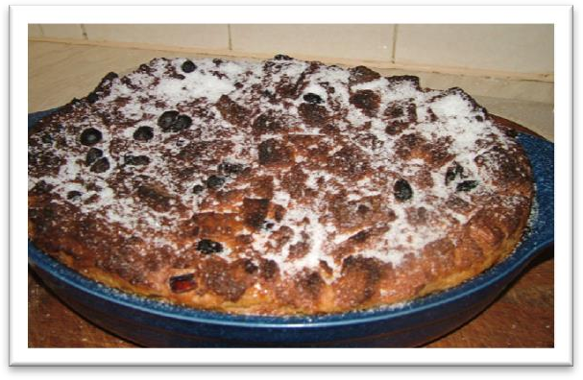

trip / stumble over / on sth. 在……上绊倒

He tripped / stumbled over / on a rock. Chairs and tables went flying into the arcade.

The Titanic turned just in time, narrowly missing the immense walk of ice which rose over 100 feet out of the water beside her.

mirth n. [U] (fml.) happiness and laughter 欢笑

Her body began to shake with mirth.

The performance produced much mirth among the audience. That caused considerable mirth amongst pupils.

draw / come to / arrive at / reach a conclusion 得出结论

**bring … to a conclusion 使……结束**

In the nineteenth century, a novelist would bring his story to a conclusion by presenting his readers with a series of coincidences — most of them wildly improbable.

The guests had, of course, realized this from the moment Bessie opened the door for them and,

*long before the final catastrophe*, had had a difficult time trying to conceal their amusement. The telephone rings and this marks the prelude to an unforeseen series of catastrophes. have a difficult / hard time doing

After her departure, aunt Harriet discovered that there were piles of empty wine bottles of all shapes and sizes *neatly stacked in what had once been Bessie's wardrobe*.

… of all shapes and sizes

Before long, biscuits of all shapes and sizes began arriving at the factory.

… of all kinds

…, vehicles of all kinds, especially large container trucks thundering through quiet villages, …

find one’s way 到达……

Very few of the fifty pence pieces and pound coins I have given him have found their way there.